RGB Animation Laser
User Manual

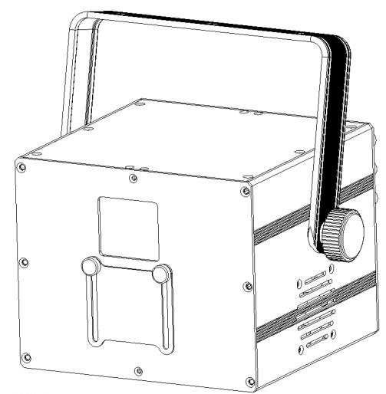

3W

Please read this manual carefully before use!

Contents

Introduction--------------------------------------------------------------------------------------------------P2

Silkscreen on product------------------------------------------------------------------------------------P3

Safety instruction/Installation/Technical specification----------------------------------------P4

Menu-----------------------------------------------------------------------------------------------------------P5

DMX512 Channel------------------------------------------------------------------------------------------P6

DMX Adress setting/DMX512 connection---------------------------------------------------------P8

Product size/Ringing--------------------------------------------------------------------------------------P9

Cleaning and maintenance/Warning/Warranty card-------------------------------------------P10

Introduction
Thank you for purchasing this product. To optimize the performance of this product,prior to use,please read these operating instructions carefully to familiarize yourself with the basic operation of this unit.Please keep the manual in safe price for future reference.
This unit has been tested at our factory before being shipped to you, there is no assembly required.
Once after received this product , please take and put carefully. And check cautiously that whether the product was damaged or not during the transportation.

Checking Parts
Please check if the following parts are included:
1 x Laser light
1 x User manual
1 x Power cable

Caution



CAUTION!

Keep this device away from rain and moisture!

Unplug mains lead before opening the housing!

Warning!


Damages caused by the disregard of this user manual are not subject to warranty. The dealer will not accept liability for any resulting defects or problems.

Symbol Instruction On The Device

…


-------------------------------------------------------------------------------CE Certificate
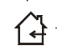

---------------------------------------------------------------------Only indoor use



------------------------------------------------------------------------Environmental protection


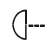
----------------------------------------The minimum distance from lighted objects(meter)

------------------------------------------------------------Max. Ambient Temp

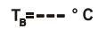
----------------------------------------------------Max. Housing Temp



------------------------------------------------------------------------- Safety caution



-------------------------------------------------------------------------Careful burns



------------------------------------------------------------------------Careful electric shock

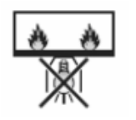

-----Not suitable for directly installed on the surface of ordinary combustible materials

Safety Instructions

- Please open and check whether break or not for transport once receive this fixture, if yes, not use it and contact dealer or manufacture as soon as possible.
- The Max applicable temperature for the light is 40°C. Do not use the light under or above the temperature. ta=40℃
- The fixture is applicable for many occasions, it should keep clean, and avoid long use in overheating or dusty environment. To prevent the fixture from the chemical liquid .
- User must be careful of fire, heat, electric and fall-off that make heavy or fatal injury. Please read this user manual carefully before power on and installation, following safety and operation instruction in it. If still have any questions, please contact dealer or manufacture.
- User must following this user manual, do not open fixture by yourself, if any problems, please contact professional technician, maintenance should by technician.
Do not power on or start the fixture before installation, please stop after working more than 8 hours, which will longer use life.
- Fixed installation, do not by strong shocks.
- The minimum distance between light and the illuminated surface must be more than 1 meter. 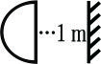
- Never look directly into the light source to avoid hurt to eyes (especially epileptics)!
When dustproof glass at light output breaks, cracks or other visible damage, user should replace with new glass to continue to use.

Installation
- When install this equipment please make sure there's no flammable surfaces (decorated things, etc) and minimum distance of 0.5M from the equipment to the flammable.

- The installation of the effect has to be built and constructed in a way that it can hold 10 times the weight and without any harming deformation.
- The installation must always be secured with a secondary safety attachment, e.g. an appropriate safety rope.Never stand directly below the device when mounting, removing or servicing the fixture.

Technical Specifications
Input voltage: AC100-240V, 50/60Hz
Fuse: BGDP ￠5x20mm 250VAC F2A
Total power:75W
Light source: 3W RGB
Control mode: Auto/Sound/DMX512/ILDA/Master-slave
Channels：21CH
Scanning system: 30Kpps Scanner, ±30º
Surface temp: Tb=45ºC ( this data testing when the environment temp is 30ºC)
Working temp: 10ºC--65ºC
Modulation: Analog modulation
N.W: 4.1Kg
G.W: 5Kg
Carton packing size: 30*25*26cm

Laser control system
1. MENU operation

Rotate the knob at display’s right side to operate the menu, press knob to enter sub-menu or exit menu, after operation, Non-stop Three time-click the knob to save the option and exit the menu, once back DMX display means success record and setting.(Eg: when setting DMX address should Non-stop three time click the knob and exit MENU, till back to DMX display, then DMX address can success save)

Below the display, safety key location, is closed the laser when the key at OFF, and is open when the key at ON.
- MENU display
MENU | UP/DOWN | Default | Function
DMX ADDR | 1-512 | 1 | DMX address setting
CHANNEL | 21CH | 21CH | 21CH
CHANNEL | 32CH | 21CH | 32CH (Hold)
CHANNEL | 64CH | 21CH | 64CH( Hold)
MODE | ILDA | BREAK | ILDA mode，display shows in ILDA file circularly（file’s expanded-name is ILD）
MODE | AUTO | BREAK | Auto
MODE | SOUND | BREAK | Sound
MODE | SLAVE | BREAK | Slave
MODE | BREAK | BREAK | Standby
MODE | ILD X | BREAK | ILD X, random play
MODE | ILD 0---ILD 255 |  | ILD files single play
SPEED | 0-100 | 100 | Auto speed from slow to fast
SENSE | 0-100 | 90 | Sound sensitivity adjust
SIZE | 10-100 | 100 | Set pattern size
PHASE XY | X+ Y+ | X+ Y+ | X+ Y+
PHASE XY | X- Y+ | X+ Y+ | X- Y+
PHASE XY | X+ Y- | X+ Y+ | X+ Y-
PHASE XY | X- Y- | X+ Y+ | X- Y-
SCANER | 20K-40K | 30K | Scanner speed
DIM R | 0-100 | 100 | Red dimmer
DIM G | 0-100 | 100 | Green dimmer
DIM B | 0-100 | 100 | Blue dimmer
LANGUAGE | CH/EN | EN | Language option

DMX Channel Instructions

21CH

Channel |  | Value | Function
CH1 | Dimmer | 0-255 | 0-100%
CH2 | Color control | 0-69 | White-Red-Blue-Pink-Cyan-Yellow-Green(fixed color option)
CH2 | Color control | 70-79 | Color change (eotic speed controlled by CH3)
CH2 | Color control | 80-89 | Default color (eotic speed controlled by CH3)
CH2 | Color control | 90-94 | Rainbow color (eotic speed controlled by CH3)
CH2 | Color control | 95-114 | 2 segement color option, 5 data stepping  (eotic speed controlled by CH3)
CH2 | Color control | 115-139 | 3 segement color option, 5 data stepping  (eotic speed controlled by CH3)
CH2 | Color control | 140-164 | 4 segement color option, 5 data stepping  (eotic speed controlled by CH3)
CH2 | Color control | 165-189 | 8 segement color option, 5 data stepping  (eotic speed controlled by CH3)
CH2 | Color control | 190-224 | 16 segement color option, 5 data stepping  (eotic speed controlled by CH3)
CH2 | Color control | 225-229 | Color dynamic eotic 1(eotic speed controlled by CH3)
CH2 | Color control | 230-234 | Color dynamic eotic 2(eotic speed controlled by CH3)
CH2 | Color control | 235-239 | Color dynamic eotic 3(eotic speed controlled by CH3)
CH2 | Color control | 240-244 | Color dynamic eotic 4(eotic speed controlled by CH3)
CH2 | Color control | 245-249 | Color dynamic eotic 5(eotic speed controlled by CH3)
CH2 | Color control | 250-255 | Color dynamic eotic 6(eotic speed controlled by CH3)
CH3 | Color eotic speed | 0-9 | Without eotic
CH3 | Color eotic speed | 10-127 | Color clockwise eotic, speed from slow to fast
CH3 | Color eotic speed | 128-255 | Color anti-clockwise eotic, speed from slow to fast
CH4 | Light dot color option | 0-255 | Pattern light dot color: White-Red-Blue-Pink-Sycan-Yellow-Green(CH7 75-99 Valid)
CH5 | Strobe | 0-2 | No strobe
CH5 | Strobe | 3-255 | Strobe from slow to fast
CH6 | Pattern option | 0-255 | Pattern option (controlled by CH7, total 10 patterns)
CH7 | Pattern group option | 0-24 | Built-in group 1
CH7 | Pattern group option | 25-49 | Built-in group 2
CH7 | Pattern group option | 50-74 | Built-in group 3 （
CH7 | Pattern group option | 75-99 | Built-in group 4
CH7 | Pattern group option | 100-124 | Built-in group 5
CH7 | Pattern group option | 125-149 | ILDA animation group 1
CH7 | Pattern group option | 150-174 | ILDA animation group 2
CH7 | Pattern group option | 175-199 | ILDA animation group 3
CH7 | Pattern group option | 200-224 | ILDA animation group 4
CH7 | Pattern group option | 225-255 | ILDA animation group 5
CH8 | Pattern zoom | 0-63 | Pattern size option
CH8 | Pattern zoom | 64-127 | Speed option from small to larger
CH8 | Pattern zoom | 128-191 | Speed option from larger to small
CH8 | Pattern zoom | 192-255 | Zoom speed option
CH9 | center rotation | 0-127 | Angle option
CH9 | center rotation | 128-191 | Clockwise speed option
CH9 | center rotation | 192-255 | Anti-Clockwise speed option
CH10 | Horizontal rotation | 0-127 | Flip horizontal direction option
CH10 | Horizontal rotation | 128-255 | Flip horizontal speed option
CH11 | Vertical rotation | 0-127 | Flip vertical direction option
CH11 | Vertical rotation | 128-255 | Flip vertical speed option
CH12 | Pan move | 0-255 | vertical direction option
CH13 | Tilt move | 0-255 | vertical centre location
CH14 | Horizontal wave | 0-9 | No wave
CH14 | Horizontal wave | 10-255 | Wave range and speed adjust(range from small to big, speed from slow to fast, every 32 data as one group, total 8 group)
CH15 | Vertical wave | 0-9 | No wave
CH15 | Vertical wave | 10-255 | Wave range and speed adjust(range from small to big, speed from slow to fast, every 32 data as one group, total 8 group)
CH16 | gradual drawing | 0-1 | no drawing
CH16 | gradual drawing | 2-63 | gradual drawing by manual adjust 1
CH16 | gradual drawing | 64-127 | gradual drawing by manual adjust 2
CH16 | gradual drawing | 128-153 | auto gradual drawing （increasing）
CH16 | gradual drawing | 154-179 | auto gradual drawing （decreasing）
CH16 | gradual drawing | 180-205 | Auto gradual drawing( increasing to decreasing, reverse)
CH16 | gradual drawing | 206-255 | Auto gradual drawing( increasing to decreasing, syntropy)
CH17 | Location tracking option | 0-15 | No tracking
CH17 | Location tracking option | 16-47 | Tracking 1, range and speed controlled by CH18
CH17 | Location tracking option | 48-79 | Tracking 2, range and speed controlled by CH18
CH17 | Location tracking option | 80-111 | Tracking 3, range and speed controlled by CH18
CH17 | Location tracking option | 112-143 | Tracking 4, range and speed controlled by CH18
CH17 | Location tracking option | 144-175 | Tracking 5, range and speed controlled by CH18
CH17 | Location tracking option | 176-207 | Tracking 6, range and speed controlled by CH18
CH17 | Location tracking option | 208-239 | Tracking 7, range and speed controlled by CH18
CH17 | Location tracking option | 240-255 | Tracking 8, range and speed controlled by CH18
CH18 | Tracking range and speed | 0-63 | Small tracking, speed from slow to fast
CH18 | Tracking range and speed | 64-127 | Middle tracking, speed from slow to fast
CH18 | Tracking range and speed | 128-191 | Big tracking, speed from slow to fast
CH18 | Tracking range and speed | 192-255 | Max tracking, speed from slow to fast
CH19 | Pattern mirroring | 0-2 | No mirroring( original pattern)
CH19 | Pattern mirroring | 3-63 | X mirroring
CH19 | Pattern mirroring | 64-127 | Y mirroring
CH19 | Pattern mirroring | 128-191 | XY mirroring 1
CH19 | Pattern mirroring | 192-255 | XY mirroring 2
CH20 | Built-in dynamic | 0-1 | No function
CH20 | Built-in dynamic | 2-213 | Built-in dynamic option, speed and color controlled by CH21
CH20 | Built-in dynamic | 214-255 | Auto random, speed and color controlled by CH21
CH21 | Built-in speed | 0-127 | Speed from fast to slow, color built-in fixed
CH21 | Built-in speed | 128-255 | Speed from fast to slow, color cotrolled by console

DMX-512 connection
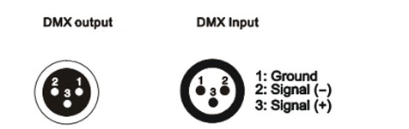

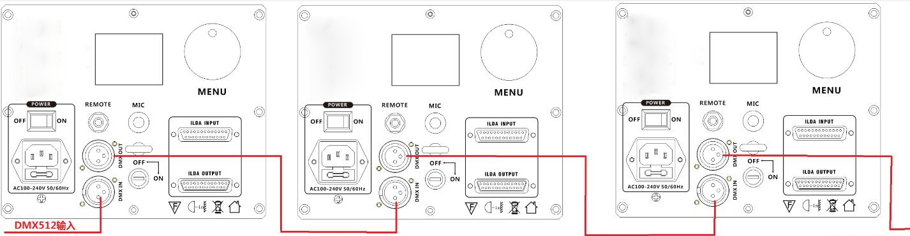
DMX In To the fourth
First light (Address 001) Second light (Address 022) Third light(Address 043)

DMX Address setting
Each fixture must set a specific starting address. When receiving signal transmission, fixture will receive channel control signals which from the starting address.
According to different requirements or easy to use, the user can set many value fixtures to the same address, also can set up a separate address for every device.
If you set the same address,all the devices will receive from DMX channels signal. All connecting fixtures are jointly controlled, controller can't separate control a device.
If you set a different address, each device will be separate from its particular set the starting address and begin accepting DMX512 control signal, so that more convenient separate control one device. Using this method must be based on channel quantity of device to determine a starting address.
This laser light has 21 channels.you should set the starting address of the first unit to 1, the second unit to 22(1 + 21), the third unit to 43 (21*2+ 1), and so on.

Product Size
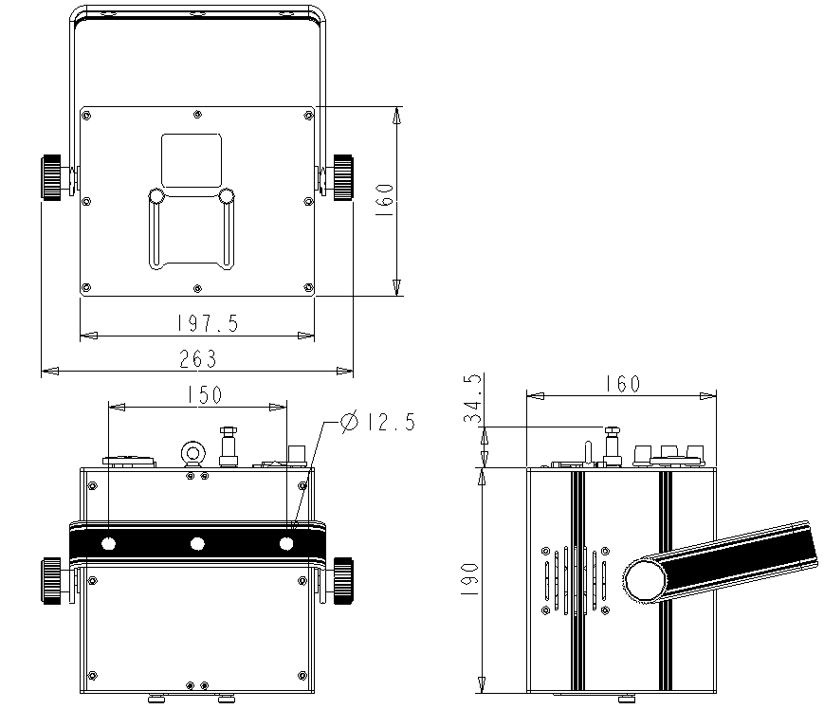

Ringing

1 Mounting bracket
2 Handle

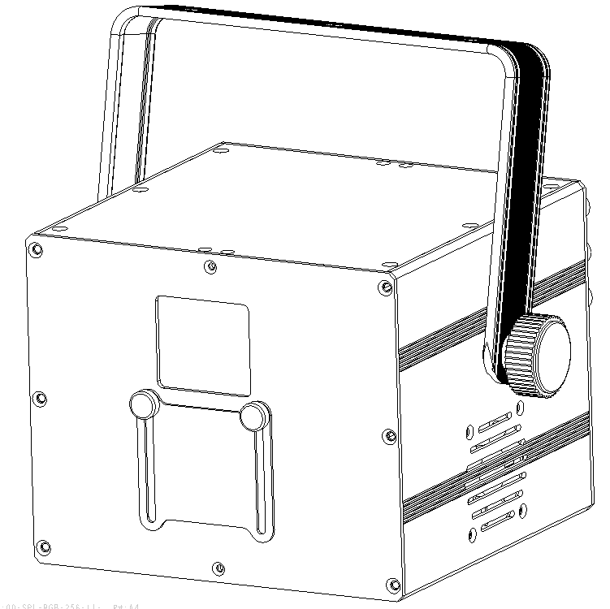
- .The ambient temperature range is 1°C--45°C, must never be exceeded.
- .The installation of the projector has to be built and constructed in a way that it can hold 10 times the weight for 1 hour without any harming deformation.
- ).When rigging or servicing the fixture staying in the area below the installation place, on bridges,under high working places and other endangered areas is forbidden.
D).The operator has to make sure that safety-relating and machine-technical installations are approved by an expert before taking into operation for the first time and after changes before taking into operation another time.
E).The operator has to make sure that safety-relating and machine-technical installations are approved by a skilled person once a year.
F). Sure M8 screws on mounting bracket fixed middle hole ¢12.5mm of handle
Cleaning and maintenance

Maintenance should be performed every 15-day period, by using a sponge which is dipped with alcohol, rather than wet cloth or other chemical liquid, to clean the mirror.

Always disconnect from the mains when the device is not in use or before cleaning it.

Caution
Make sure power off before cleaning and maintenance!

Warning

Warning!
Never look directly into the light source,as sensitive persons may suffer an epileptic shock(especially meant for epileptics)!
Caution

Warning!
Any power connected must by professional person


Warranty Card
This product is made of high-brightness transistor. We will provide 1 year warranty under the condition that user has operated the light normally and lifetime service. We won't provide warranty if the damage is caused by artificial or force majeure event. Cost of fittings should be charged by user if product need maintenance after 1 year .Please cut this warranty card and shipped it along with the product to our factory when applying for warranty.
Product：
Purchasing date：
Code of invoice：
Warranty date: From To
User’s name： Add：
Company： Tel：

